**CHAPTER THREE**

**PROJECT METHODOLOGY**

**3.1 Implementation Methodology**

Memo Management System implementation process (the development phase) involved decomposing the whole system into modules and defining the relationship among the constituent modules. This project work was accomplished using the Top down design approach. This involved dividing the system into subsystems (modules) and each subsystem being further divided into even smaller subs. This process of division is repeated until each module is sufficiently small enough to be conveniently coded from scratch as an independent entity that carries out a clearly defined task.

The analysis and comparison of existing manual memo management methods of organizations was done and this was arrived at from the review of related designs. The critical analysis led to the adoption of the scheme of requirement specifications that highlighted the nature of the online memo management implemented in this project work. Online memo system implementation process is all about creating a web platform (an online system) that facilitates internal communications within Ajayi Crowther University. The performance evaluation made provided a deep insight into creating a virile web based application that serves as a central meeting point for both administrative staff, lecturers, student representatives of various students associations and other non-teaching personnel of the university. The process followed in the design and implementation of the online memo management system is concisely analysed as follows.

**3.2 The System Design phase**

Collection and downloading of the applications (software) needed was the first phase of the implementation. Then the wireframe and planning of the application was done on paper. Collection of the objects needed for the database and models was planned and drawn on paper. The Entity relationship between the database tables was done on paper and then finally done on MySQL workbench to know the relationships between tables and table objects as shown in the diagram on the next page (Figure 3.1).

The User table has columns id, firstname, lastname, email and password, status, created where the email will be used to sign in for users since email for every user will always be unique. Two users cannot have the same email, so email is always different and checked if it has existed upon registration. The status in the user table is used in checking the status of a user if the user is an admin (who is likely the secretary to the Vice Chancellor, VC, or the head of Human Resource, HR, department) or a regular staff (lecturer, student representative, non-teaching staff etc.). These following entities can be identified specifically for the system being developed, admin, category, user, faculty, department, memo, etc. System administrators can add users, departments, faculties, etc., they can send memo to every staff, fellow admins and student representatives as well and they can ‘view’ all staff, fellow admins and student representatives that have registered on the application. A non-admin user can receive and reply to memos from an admin and other users, they can send memos to other users in the same faculty or department (especially those under their command, who they are eligible to send memos to). The category table is for the kind of memo (academic, repairs, sports, community service etc.) that is being sent to a staff. The users table has a “1 to many” relationship with the category table, this means a user can has access to many categories of memos on the online platform which allows the administrator to choose the memo category id and make sure the memo has been created before they can send to other (all or selected) staff. The faculty and department columns are used to separate users into their various departments and faculties so communications will be made easy and confined within the set boundaries. A database was then created for the project on MySQL using PHPmyAdmin as shown in the following figure 3.2.

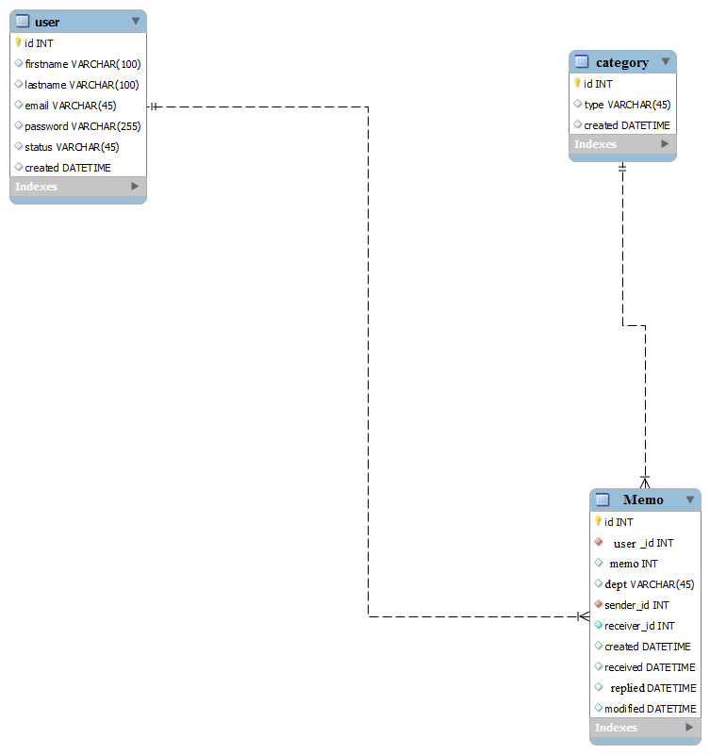

Fig 3.1 Entity Relational Diagram (The Relationship between Tables)

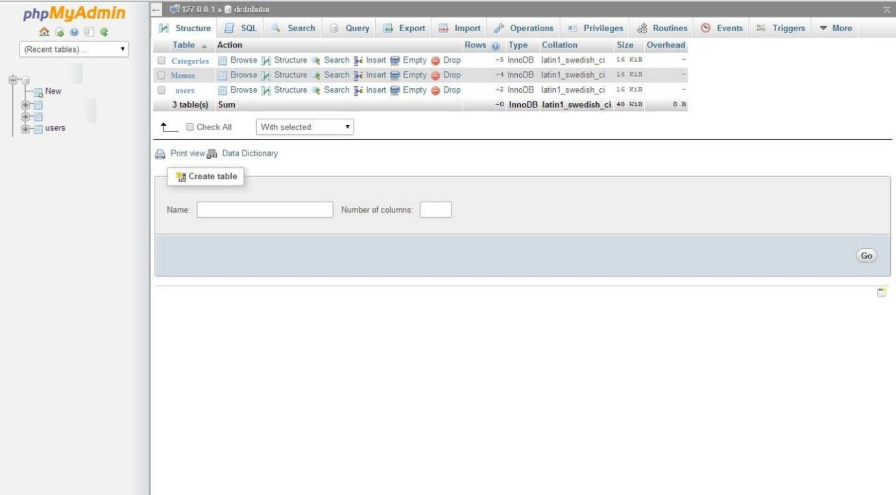

Figure 3.2 Database for the application using MySQL on PhpMyAdmin

After the database creation for the application; the tables needed (Users, memos and categories) were then created as shown in figures 3.3 to 3.5. The data structures of the entities on the database are as shown in Table 3.1. The tables were created, then design of the landing (home) page was done with HTML and CSS and the backend was written in PHP to accept users’ input via login form and save them, but as a non-activated user and as a member (not a staff, student representative or lecturer) the code snippets that does this is shown in the source code given in the appendix. When users login, the dashboard page that will be loaded will depend on the status of the user, whether admin or non admin user. When users get to the landing page, the details of memos sent/received are seen, displayed for the user to access, view their received and sent memos, department/faculty and other necessary descriptions; then they can now accept (acknowledge receipt) all or a certain number of the sent memos. This is shown in the source code in the index script/snippet.

The Application has then been designed in a way that the manager (head of HR or secretary to the highest authority, VC) of the online memo management website or the site admin at any time can decide to add one or more people as admin and add more memo types (categories). The admin(s) will be able to add, edit, delete, and modify memos when they are needed. The admin can also add more departments, faculties or any other necessary unit whenever the university decides to begin to a new department under a new or existing faculty. This is shown in the source code by the “Admin_add, Admin_view, and Admin_delete” scripts/snippets. The non-admin users are allowed to see their memos, editing the details of the sent memos and messages as they want. This is shown in the source code by the non_admin_users script/snippet. The design process followed a clear procedure which is well represented by the flowchart as shown in figure 3.6.

Table 3.1 Some Database Table Elements and data-types

|  |  |  |
| --- | --- | --- |
| **Field Name** | **Data-type** | **Description** |
| User_id | int(11) | User identification |
| User_firstname | varchar(18) | User first name |
| User_lastname | varchar(20) | User last name |
| User_password | varchar(13) | User login password |
| User_gender | varchar(7) | User gender |
| User_phoneno | int(11) | User phone number |
| User_email_add | varchar(30) | User email address |
| memo_name | varchar(3) | Memo name |
| memo_id | varchar(3) | Memo identification |
| memo_d_o_c | Date | Memo date of creation |
| fac_id | int(11) | Faculty identification |
| fac_name | varchar(18) | Faculty name |
| dept_id | varchar(20) | Department identification |
| dept_name | Varchar(18) | Department name |
| user_password | varchar(13) | User login password |

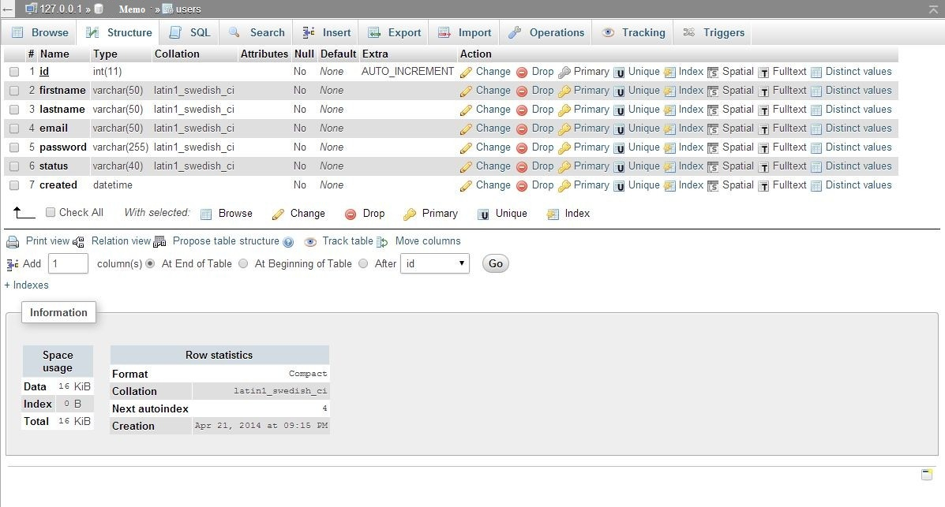

Figure 3.3 Users’ Table

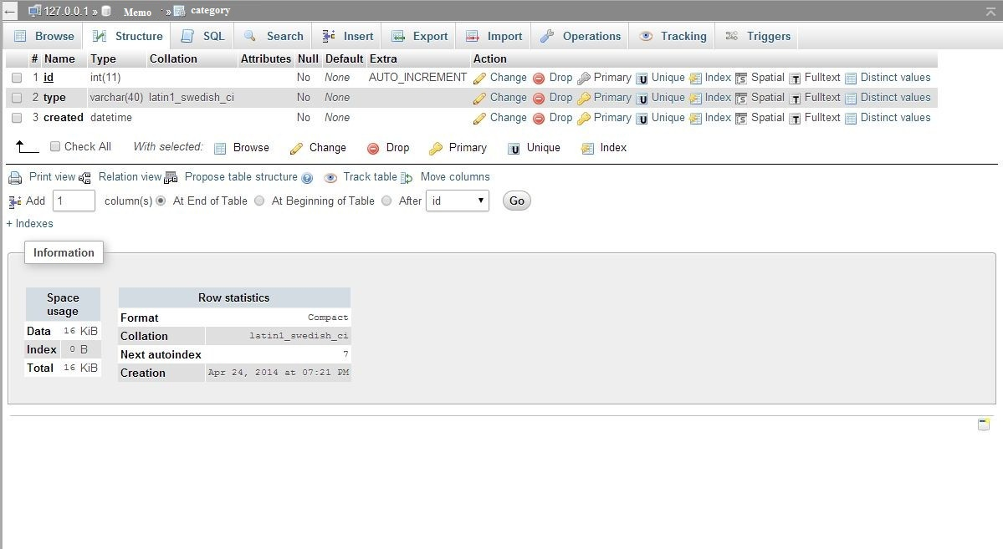

Figure 3.4 Category Table

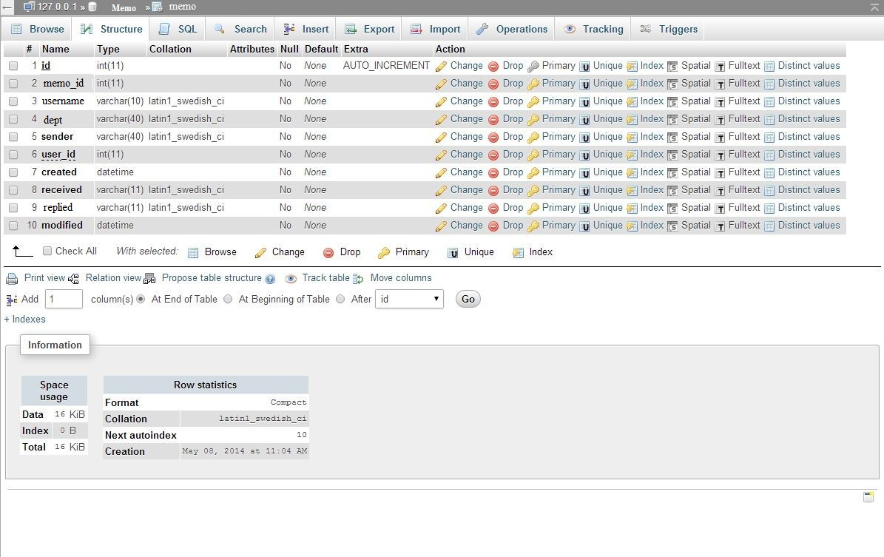

Figure 3.5 Memo Table

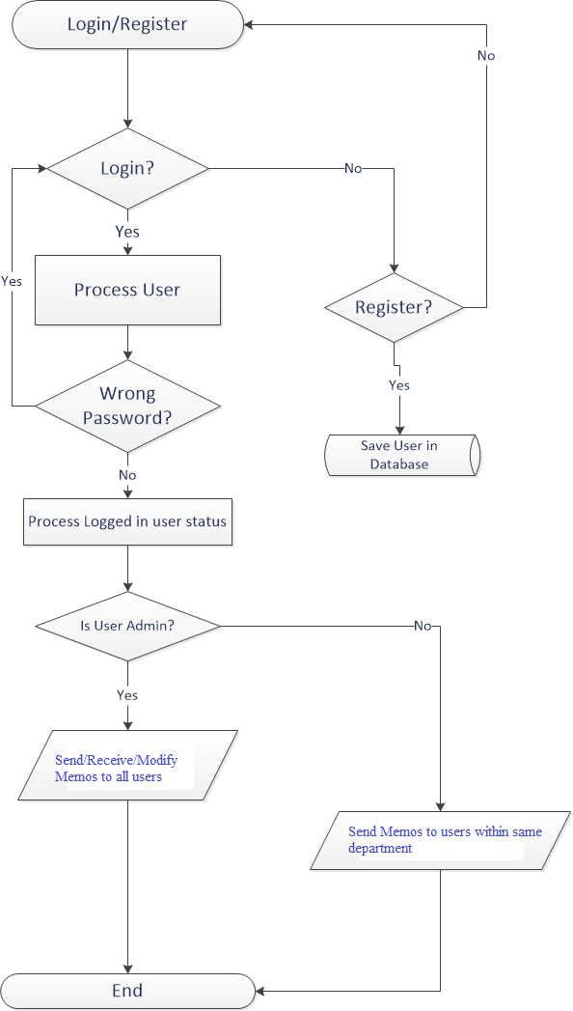

Fig 3.6 The flowchart for users’ access

**3.3 Activity Diagram**

Activity diagrams are graphical representations of workflows depicting stepwise activities and actions with support for choice, iteration and concurrency. In the unified modelling language, activity diagrams can be used to describe the business and operational step-by-step workflows of components in a system. An activity diagram shows the overall flow of control.

The activity diagram shows the visual representation of the process flow. In this e-memo system, the diagram shows how a user will navigate from one point to another on the web based app in order to getting the task of getting memo created, sent, received, replied to and well organised. The web app was developed with skilfully linked pages that followed a very orderly sequence; the landing page is the home page (index page), on the home page, the user aim is to login (after registering on the platform during the first use of the system) and attend to new memos that come in and also send memos to other users. Simply put, to organise and manage memos within Ajayi Crowther University. The admin creates the categories, faculties, departments, etc, and can also add users and every other entities of the web application software. For a user to be successfully logged in, the provided credentials must match the one stored in the database at the point of registration at the first use of the system. If the credentials are correctly supplied, the user would be taken to the home page, else he/she would be taken back to the ‘login’ page to supply the correct and matching username and password. This and more are more elaborated discussed in chapter four of this final year project report. Figure 3.7 on the next page clearly shows the data and process flow of activities in the e-memo management system.

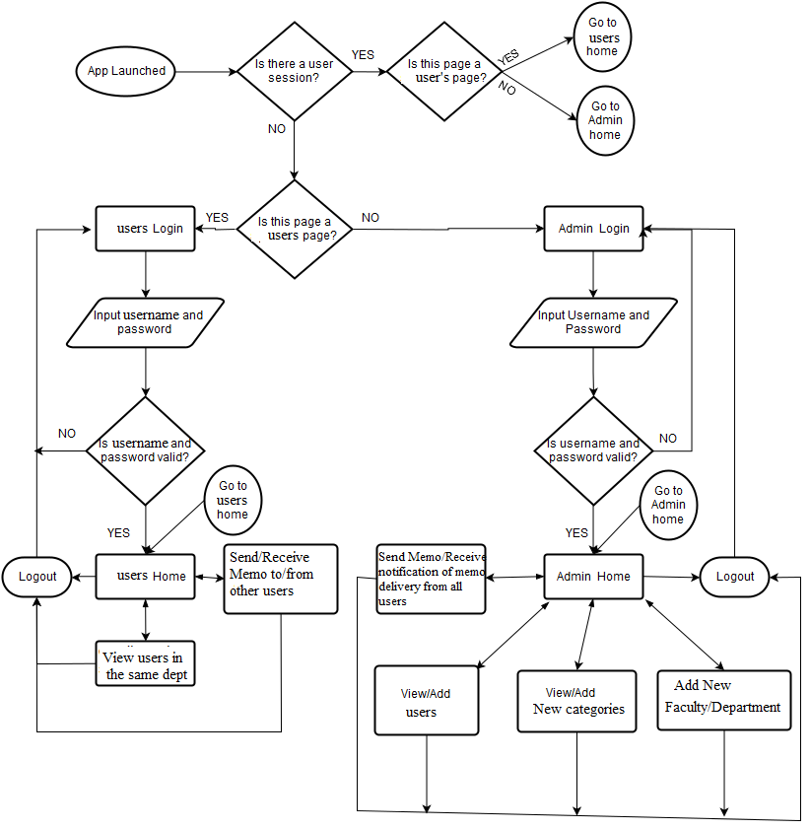

Figure 3.7 Program Activity Diagram

**3.4 Development Tools Used in System Design**

The tools used in the analysis and design of the online memo management platform made it a virile information management system. The design phase of this project was carried out by the use of the following tools:

* XHTML 1.0
* CSS 2 and 3
* PHP 5.4
* MySQL 5.5

**3.4.1 Extensible Hyper Text Mark-up Language (XHTML 2.0)**

Hyper Text Mark-up Language is the language used in this memo management web application to render the view/design for the end user’s visible on the web browser. It is the only language that the web browser normally understands. The latest version has been used for the project. The Latest version of HTML is 5 which is equivalent to XHTML 2.0 (Extensible Hyper Text Mark-up Language) was used in this online memo management project work. It is the mark-up language used in this project in rendering the PHP scripts written so the web browser can understand what is being written in the backend scripts (PHP codes/commands).

HTML is written in the form of HTML elements consisting of tags enclosed in angle brackets (like <html>). HTML tags most commonly come in pairs like <h1> and </h1>, although some tags represent empty elements and so are unpaired, for example <img>. The first tag in a pair is the start tag, and the second tag is the end tag (they are also called opening tags and closing tags).

The purpose of a web browser is to read HTML documents and compose them into visible or audible web pages. The browser does not display the HTML tags, but uses the tags to interpret the content of the page. HTML describes the structure of a website semantically along with cues for presentation, making it a mark-up language rather than a programming language. HTML elements form the building blocks of all websites. HTML allows images and objects to be embedded and can be used to create interactive forms. It provides a means to create structured documents by denoting structural semantics for text such as headings, paragraphs, lists, links, quotes and other items. It can embed scripts written in languages such as JavaScript which affect the behaviour of HTML web pages. Web browsers can also refer to Cascading Style Sheets (CSS) to define the look and layout of text and other material. The W3C, maintainer of both the HTML and the CSS standards, encourages the use of CSS over explicit presentational HTML.

**3.4.2 Cascading Style Sheet (CSS)**

Cascading Style Sheets (CSS) is the style sheet language that was used for describing the look and formatting of the document written in HTML. While most often used to style web pages and interfaces written in HTML and XHTML, the language can be applied to any kind of XML document, including plain XML, SVG and XUL. CSS is a cornerstone specification of the web and almost all web pages use CSS style sheets to describe their presentation.

Cascading Style Sheet is the mark-up language we used in this web application that made up the styling and beauty of HTML, unlike HTML where there is no beauty on the frontend of the application. CSS is the key behind every website/application that is all over the world today. The version of Cascading Style Sheet used in this project work is 3.0; CSS 2 was used in the project for all layouts while CSS 3 was used in the responsiveness, forms and buttons of the project.

CSS is designed primarily to enable the separation of document content from document presentation, including elements such as the layout, colours, and fonts. This separation can improve content accessibility, provide more flexibility and control in the specification of presentation characteristics, enable multiple pages to share formatting, and reduce complexity and repetition in the structural content (such as by allowing for table-less web design).

CSS can also allow the same mark-up page to be presented in different styles for different rendering methods, such as on-screen, in print, by voice (when read out by a speech-based browser or screen reader) and on Braille-based, tactile devices. It can also be used to allow the web page to display differently depending on the screen size or device on which it is being viewed. While the author of a document typically links that document to a CSS file, readers can use a different style sheet, perhaps one on their own computer, to override the one the author has specified. However if the author or the reader did not link the document to a specific style sheet the default style of the browser will be applied.

**3.4.3 Hyper Text Pre Processor (PHP)**

PHP (Hypertext Pre-processor) is a server scripting language, and a powerful tool for making dynamic and interactive web pages. PHP was used for the development of the new system to enhance the web pages. The PHP was used to create the login form, registration form, memo composition template and so on and was also used for validation and verification of this details in the database. The PHP was use to collect user information as well as interact with MySQL databases. PHP is designed for web development but also used as a general-purpose programming language. PHP code is interpreted by a web server with a PHP processor module, which generates the resulting web page: PHP commands can be embedded directly into an HTML source document rather than calling an external file to process data. It has also evolved to include a command-line interface capability and can be used in standalone graphical applications. PHP 5.4 was used in the implementation of the online memo control project.

Hyper Text Pre Processor is a backend programming language for web applications, when some commands are written and directed to the HTML to process and lay out to the browser based on the PHP codes written behind the scenes, where the output will be programmatically processed by the “hidden codes”; the website is then called a web application. PHP has been used in the project to accept users’ input, process it and perform some actions on it. e.g.: saving registered guests in database and restricting them to login until they are approved. PHP was used in this project to interact with database tables using MySQL. PHP is free software released under the PHP License. PHP can be deployed on most web servers and also as a standalone shell on almost every operating system and platform, free of charge, because it is open source.

**3.4.4 MySQL (Structural Query Language)**

MySQL is a widely used open-source relational database management system (RDBMS). SQL is a standard language for accessing database. It is an open-source relational database management system. MySQL was used to add, access and process data stored in a computer database. MySQL is a popular choice of database programming for use in web applications, and it is a central component of the widely used LAMP open source web application software stack (and other 'AMP' stacks). LAMP is an acronym for "Linux, Apache, MySQL, Perl/PHP/Python." Free-software-open source projects that require a full-featured database management system often use MySQL. MySQL 5.5 was used in the implementation of this project work.

MySQL workbench is a tool in MySQL 5.5 database programming language used in drawing and linking different database tables. This tool is used to know the relationships between two or more tables/models. Before an application is being started; the developer is required to know how many tables the application database will have and the relationship between them, so as to have a clear understanding of what is meant to be coded.

**3.5 Procedure Phases and Time Frame**

The implementation of the memo management project was divided into the following phases:Requirement phase, Analysis Phase, Design phase, Implementation and testing phase

* Requirement phase: Here, a complete description of the behaviour of the system was done. The interaction users would have with the software was clearly mapped out for clear development (coding).
* Analysis Phase: Formal enquiry was carried out in order to identify a better course of action to develop the system, thoughts were shared, and online resources were perused for clear information.
* Design phase: The Graphical User Interface for the mobile application was developed. This was done using HTML.
* Implementation Phase: This is the part of the process where the software engineering of the expert system was actually done. The coding from scratch using PHP and MySQL. Scripts for different modules were written and fully tested okay. This phase is in progress.

The project is to be completed in a six month timeline (first and second semesters). It is divided into two segments completed in each semester. The first segment is the gathering of relevant information and other resources for the successful completion of the project, this entailed the preparation of the chapter one (introduction) and two (review of literatures on past related works) of the project report. The second segment involved the actual implementation and discussion of the results attained.